**Sprint 4 Plan**

Summarize Everything

Summarize Everything

End: Mar 8, 2022

Revision: 1

Revision Date: Feb. 23, 2022

**Goal:**

Have a better UI, give advice on model choice, and accept more URL links.

**Task listing (Organized by user story):**

*User story 1:* As a user I would like to summarize news articles using general URL links (i.e. not just NY Times articles) (13 points)

*Task 1:* Get article writing from general news/article sites (3 hours)

*Total for user story 1: 3* ***hours***

*User story 2:*  As a user I would like to have unit tests for the website. (21 points)

*Task 1:* Create unit tests (4 hours)

*Task 2:* Doing test and debug (12 hours)

*Total for user story 2: 16* ***hours***

*User story 3:* As a user I would like to choose between the top 3 performing models. (5 points)

*Task 1:* Figure out the accuracy and average time of models. (8 hours)

*Task 2:* Configure model select dropdown to display top models. (4 hours)

*Total for user story 3: 12* ***hours***

*User story 4:* As a user, I would like to have the system automatically notify or prevent repeat queries.

*Task 1:* Prevent multiple simultaneous queries. (4 hours)

*Total for user story 4: 4* ***hours***

**Team Roles:**

Jess Fan: Project Owner, Developer

Pushu Zhang: Developer

Janet Zhu: Scrum Master, Developer

Sebastian Medina: Developer

Victor Ho: Developer

**Initial task assignment:**

Jess Fan:

*User Story* -

*Initial Task* -

Pushu Zhang:

*User Story* - Story 2

*Initial Task* - 2.2

Janet Zhu:

*User Story* - Story 2

*Initial Task* - 2.2  
Sebastian Medina:

*User Story* - Story 1

*Initial Task* - 1.1

Victor Ho:

*User Story* - Story 2

*Initial Task* - 2.2

**Initial burnup chart:**

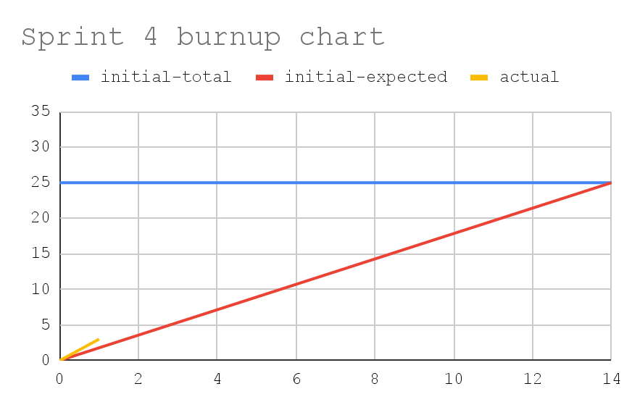

**Initial scrum board:**

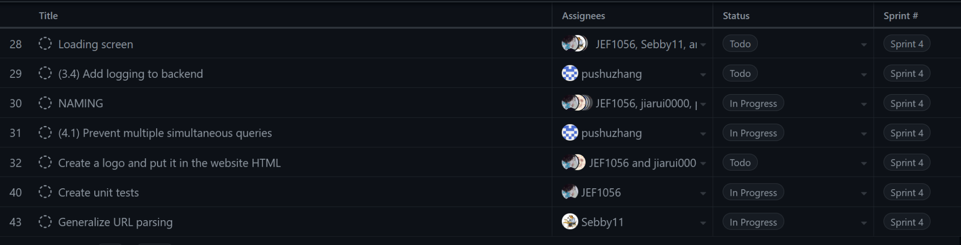

**Scrum times:**

* Monday: 8pm - 9pm
* Wednesday: 8pm - 9pm
* Friday: 3pm - 4:30pm [**TA meeting** 3pm - 4pm]